3.43: a)
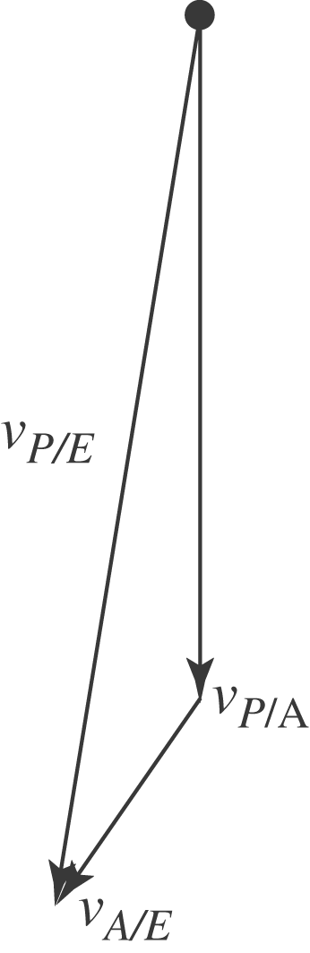

b) .
c) , south of west.

